New Product Codes

The Blood Connection would like to provide you with new products codes that will result from upcoming operational changes.

Red Blood Cells Collected by Automated Technology

TBC has recently implemented new red cell apheresis technology that is being deployed on our mobile units. Using the Alyx platform (Fresenius-Kabi), TBC will be able to collect double RBC units from a single donor. These RBC units will be leukoreduced and stored in ACD-A.

Single Unit Label
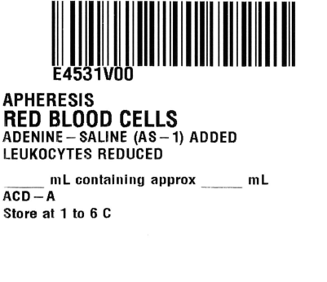

Multiple Container Label (2 parts)
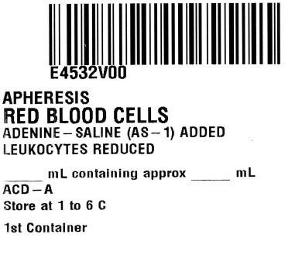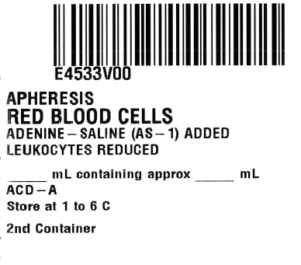

Irradiated Single Unit Label

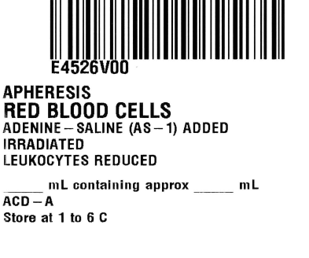

Irradiated Multiple Container Label (2 parts)

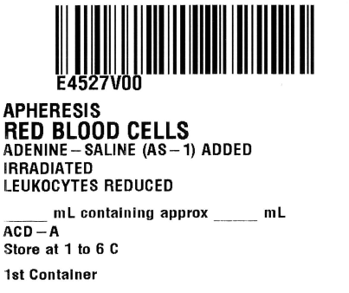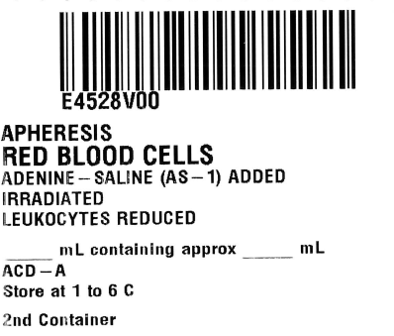

Blood Bag Change

TBC has been notified by our current blood bag provider (Terumo) that it will be discontinuing the production of the bag we currently use. As a result, TBC will be changing to a new vendor (Fresenius-Kabi) in June 2020. Although the dating and storage conditions of the prepared pRBC components will not change, there is different additive solution that will require a label change (from AS-5 to AS-1). The new product codes are listed below so that you can add them to you LIS:

RBC Label Irradiated RBC Label
