Use of Group O Packed Red Blood Cells

In June of this year, AABB released a bulletin outlining recommendations for transfusion services to use to decrease the over-reliance on Group O Rh (D)-negative Red Blood Cells.

http://www.aabb.org/programs/publications/bulletins/Documents/ab19-02.pdf

The bulletin calls for blood centers to work with their customers to optimize the use of this precious resource. TBC currently collects O-Negative RBCs at a rate of 12-14% of its total collections (a rate more than twice that of normal ON population.) This collection rate maintains the emergency needs of our trauma centers (optimal consumption at 12% or less) and normal rates of consumption by non-trauma centers; however, habitual “overstocking” is causing an imbalance in the day-to-day availability of O-Negative RBC. TBC will continue to monitor the overall level of O-Negative RBCs in our system and would encourage you to continue to review the Hospital Utilization Reports provided by our Hospital Relations team. These reports provide essential data, specifically tailored for your facility and benchmarked against other similarly-sized hospitals.

Alternate Products for O-Negative Packed Red Blood Cells

TBC would like to offer some alternative options regarding O-Negative RBCs. As we are sure you are aware, maintaining sufficient levels of O-Negative RBCs for our customers is a daily challenge faced by all blood providers and we would ask that you help us deliver on our mission. If you would please consider the following products we believe we could better balance the inventory needs of this rare commodity.

Low-Titer O-Positive Whole Blood
TBC is pleased to offer Low Titer Type O-Positive Whole Blood (LTOWB). Low Titer Type O Whole blood is most commonly used in trauma settings where massive blood loss has occurred, such as hospital emergency rooms. The Low Titer Type O Whole Blood program was first implemented by the military because of the need for safe and immediate blood transfusions in the field. This program has also shown advantages in the civilian world by providing whole blood for use in trauma situations. Low Titer Type O Whole Blood is also being stored on helicopters and first responder vehicles, as well as emergency rooms, to provide immediate care to trauma victims.
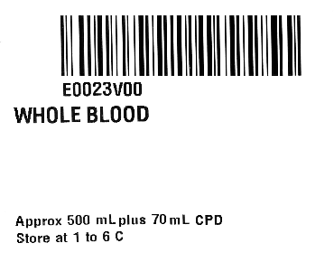
For more information related to LTOWB, the following link is for a presentation presented by Dr. Donald Jenkins in 2018 at a national whole blood symposium:
https://www.strac.org/files/Research/AMPAG_Whole_Blood_09_2018.pdf
CPDA-1 O-Negative Packed Cells:

Primarily collected for the pediatric population, often times these units are not used (due to low demand) and are available for adult transfusion. Please ensure that the follow product code is entered into your LIS so that you may receive this product as a substitute.

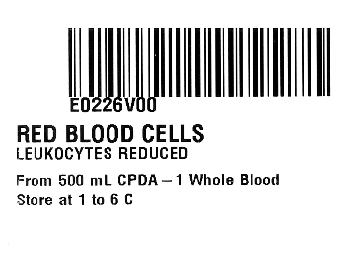

De-glycerized O-Negative Packed Cells

TBC maintains a small inventory of frozen O-Negative RBCs for emergencies. These products are frozen, thawed and de-glyced using a closed system which allows for a 14-day expiration. Please ensure that the following product code is entered into your LIS so that you may receive this product as a substitute.

